+

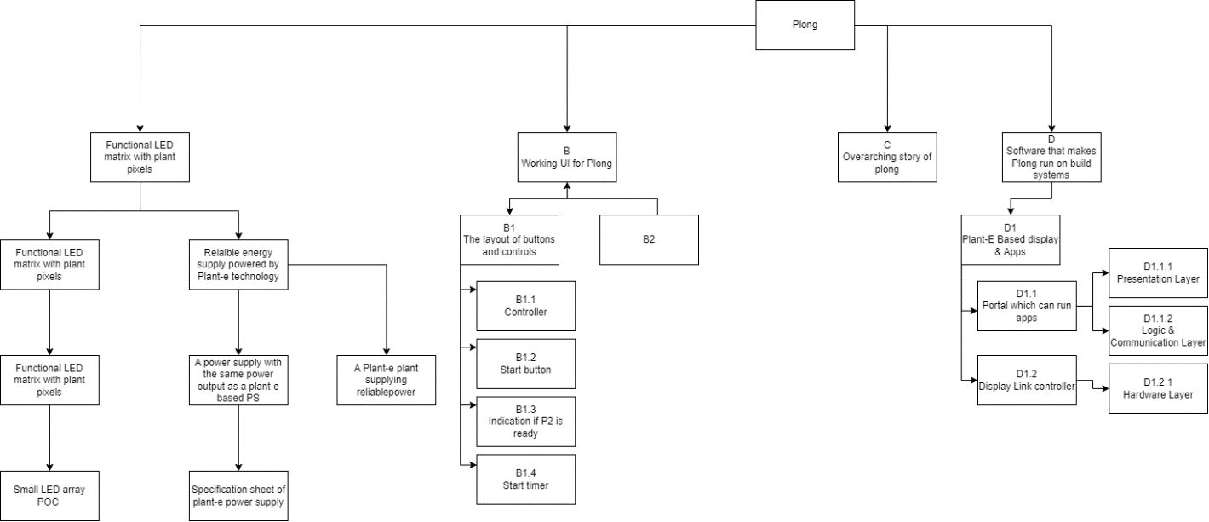

**Project Plan**

***Plant-E Glow***

*Glow*

|  |
| --- |
| **Date** **:** **31-3-2024** |
| **Version** **:** **V0.3** |
| **State** **:** **Progress** |
| **Author** **:** **Projectgroep Glow** |

#### Version history

|  |  |  |  |  |
| --- | --- | --- | --- | --- |
| **Version** | **Date** | **Author(s)** | **Changes** | **State** |
| V0.1 | 31-3-24 | Mark | Made up projectplan. | Progress (initial) |
| V0.2 | 31-3-24 | Floris | Changed items 1.1 + 1.2 + 1.4 | Progress (initial) |
| V0.3 | 31-3-24 | Merlijn | Changed items 1.5 + 2.1 | Progress (initial) |
| V0.4 | 02-4-24 | Piotr | Changed items 3.1 + 3.2 | Progress (initial) |

**Distribution**

|  |  |  |
| --- | --- | --- |
| **Version** | **Date** | **Receivers** |
|  |  |  |
|  |  |  |

Contents

1. Project assignment 4

1.1 Context 4

1.2 Goal of the project 4

1.3 Scope and preconditions 4

1.4 Strategy 4

1.5 Research questions 4

1.6 End products 4

2. Project organisation 6

2.1 Stakeholders and team members 6

2.2 Communication 6

3. Activities and time plan 7

3.1 Phases of the project 7

3.2 Time plan and milestones 7

4. Testing strategy and configuration management 8

4.1 Testing strategy 8

4.2 Test environment and required resources 8

4.3 Configuration management 8

5. Finances and risk 9

5.1 Project budget 9

5.2 Risk and mitigation 9

# Project assignment

## Context

Plant-e is a company focussed on creating climate positive energy solutions using plant based energy. The company uses the natural processes which take place between certain plants and anaerobic bacteria located at the roots to generate a steady flow of electricity which can be used to power various low power consuming I/O hardware. Examples of completed projects can be found here:

<https://plant-e.com/en/sensoren/>

<https://plant-e.com/verlichting/>

## Goal of the project

The goal of this project is to us Plant-e technology to create a series of minimal viable products (MVP’s) which lay the foundation for a product which can be set up as an art installation at GLOW. The installation can show the contrast between the usual art installations shown at GLOW, which often make use of high power consuming light projectors, and this project which is able to show an interactive piece of art while being carbon neutral/negative and using very little power.

Using plant-e technology to make an interactive art installation for GLOW will cause this technology tob e more known to the public, and further expand the use cases for this technology by using new types of IO hardware and software.

## Scope and preconditions

|  |
| --- |
| **Inside scope:** |
| 1. Functional LED matrix with plant pixels |
| 1. Working UI for Plong |
| 1. Overarching story for Plong | |
| 1. Modulair Software that runs apps on the Plant-E based display | |

*<< Indicate any preconditions. E.g., think of technology choices that have already been made by the company. Note that you are also expected to retain a critical, but constructive, mindset for choices already made >>*

## Strategy

Because the project’s scope is from a software engineering point of view, and the potential of having to redesign and change things in later stages of the project, SCRUM will be used. Sprints will be divided in timespans of 1 month, with weekly scrums to give updates on progress made on individual products in progress.

//TODO: Uitwerken

*<< Describe the strategy for your project (the approach). E.g., waterfall, or an agile approach like scrum, and justify the choice. >>.*

## Research questions

//TODO Merlijn, Floris: Uitwerken

This project has main and secondary research questions.

Main

1. Can we develop a satisfactory installation based on plant-e technology?

Secondary research questions are more aligned to the disciplines working within this project.

UI/UX

* How will the UI of Plong function?
* How do we make a good user experience for an art installation?
* Who attends GLOW?
* What defines a successful GLOW experience?
* How can we create the best user experience?
* What is the narrative?
* How can we best communicate the message to the intended audience?

Software

* Which software architecture should we choose?
* Which modules/apps need to be developed?
* Which communication method should be used?

Hardware

* How much power can be supplied with Plant-e technology?
  + On which locations can Plant-e technology be used?
* Which types of output can be used to make Plong?
* How many pixels are necessary to create a functional matrix for Plong?
  + How many plants are necessary to create this functional matrix?
  + How fast do these pixels need to react to play a game?
  + How long should the pixels be able to light up?
* What hardware should be used to translate the game to the plant-pixels?
* Research how about Plong in the water.
* Research wich way of interaction men can use.
* On wich ways can people have interaction with pong.

## End products

///TODO Floris: A

//TODO Merlijn: Rest punten in PBS zetten

*<< A Product Breakdown Structure (PBS) lists the end products that you realize, including a description of each product. In software engineering, the end products are more than just the project plan and the application itself. E.g., requirements documents, architecture documents, research reports and test reports are all end products. These are all important products that are required for effective handover. They are also necessary for further maintenance and follow up-projects. The PBS can change during the course of the project..>>*



# Project organisation

## Stakeholders and team members

|  |  |  |  |
| --- | --- | --- | --- |
| **Name** | **Abbreviation** | **Role and functions** | **Availability** |
| Chris Geene  Via Teams | Chris | Stakeholder | *When is the person available for your project (define this in the way most relevant for your project, e.g., which days are available, the amount of time, or in which phase of the project).* |
| Sandra Verhoeven  Via teams | Sandra | Stakeholder |  |
| Donovan Khoun  Via teams | Donovan | Project member  -UI/UX | *Tuesday, Wednesday, Thursday, Saturday* |
| Floris Mesu  Via teams | Floris | Project member  -Hardware | *Monday evening, Tuesday evening, Thursday (8:00 – 18:00), Friday, weekends* |
| Mark van Oirschot  Via teams | Mark | Project member  -Hardware | Tuesday, Thursday, Friday evening and in the weekend. |
| Piotr Tadrała  Via teams | Piotr | Project member  -Software | *Tuesday, Thursday, Saturday and Sunday* |
| Merlijn van der Veen  Via Teams | Merlijn | Project member  -UI/UX  -SCRUM master | Tuesday, Thursday, Friday evening and in the weekend. |

## Communication

|  |  |  |
| --- | --- | --- |
| Location of meeting | Time & date | Purpose |
| Achtseweg Zuid 151C, 5651 GW Eindhoven | 18:00 – 21:00 Tuesday | General school evening, updates to coaches and reviewing work from last week/the weekend |
| Teams | 17:30 – 18:30 Thursday | Team meeting, planning work for the weekend and talking about what has been said on Tuesday. |

# Activities and time plan

## Phases of the project

Our project is divided into four key phases:

* **Problem analysis:** Understanding the integration of plant-e technology.
* **Design & Prototyping:** Creating designs and developing proof of concepts.
* **Development:** Coding the design architecture and developing the proof of concepts.
* **Testing & Evaluation:** Validating the concept on a software/hardware/UI/UX level.

## Time plan and milestones

//TODO Donovan: Fixen

*<< For a waterfall project you can indicate the phases and milestones below (can be adapted as required).*

*For an agile project describe how the artefacts are planned. E.g., length of sprint (with justification), organization of stand up, demo, retrospective.*

*>>*

|  |  |  |  |
| --- | --- | --- | --- |
| **Phasing** | **Effort** | **Start date** | **Finish date** |
| 1. Problem Analysis |  | 05-03-24 | 24-03-24 |
| 1. Design & Prototyping |  | 25-03-24 | 21-04-24 |
| 1. Development |  | 22-04-24 | 26-05-24 |
| 4 Testing & Evaluation |  | 27-05-24 | 23-06-24 |

# Testing strategy and configuration management

## 

## Testing strategy

*For management & Control we will use GitHub for our repositories. In GitHub we will use GitHub actions to make sure for every new feature/branch a test script will be triggered. For example: for our Portal repostiory, github will create an environment where all the dependencies are installed, then github tries to build the app, and then will run a test script which will go through all unist tests.*

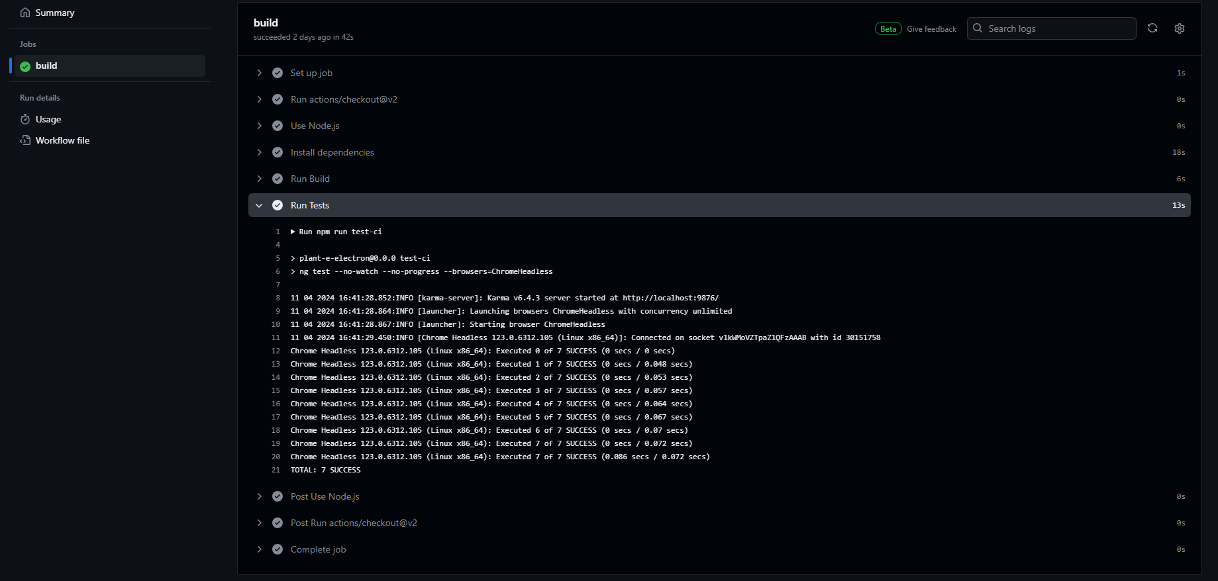

*If our code is gonna made up in C or C++ can we make use of Google-Testing. Voor de langauge Assembly of machine code there is no libary for testing that is if there is more animo for use of C/C++ code because it is not way more ineffecient in compiling as Assembly and c/c++ is more convenient in programming comparing to assembly. With google testing we can test our code and it gives us also some features to test our hardware. Google test has also featured to mocking our API's so we can test our code scripts separately.*

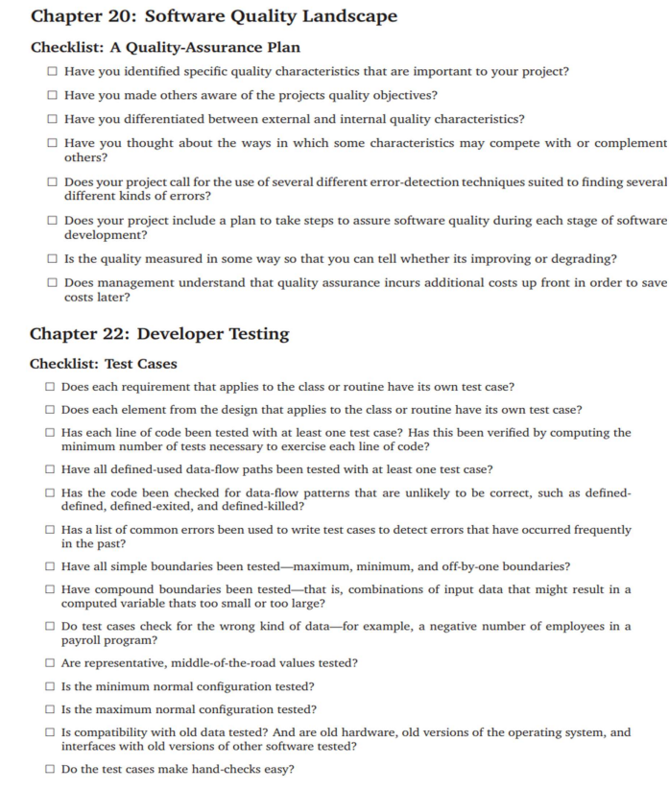

## Test environment and required resources

//TODO: Merlijn

For the UX deliverables, we need to make iterative improvements. The way we want to test this is by:

* A/B Testing
* Usability Testing
* Heuristic Evaluation
* Prototype Testing
* Surveys and questionnaires

This means that having access to people who are willing to test our concept is crucial. We can further subdivide the testing audience to have quality and quantity:

* Key users (representation of our target audience) for quality which we cherry pick
* Random people we approach through various means

*<< Describe the test environment. E.g., do you envision a DTAP (Development, Testing, Acceptance, Production) environment. Can you make use of a CI/CD environment or will you develop your own?*

*It often helps to use a picture to visualize the test environment.*

*>>*

To make clear our project group is the intention to do a once delivery for our project and not a continious improvement application for a costumer. So it is better to go for a DTAP (Development, Testing, Acceptance, Production).

*If you already know, describe which resources are required for realization and testing. Think of hardware, cloud environments and specific tooling required for development and testing.*

*------ We will make this clear in a later stadium after we make our design like a flow diagram and our plan.-----*

## Configuration management

*We are gonna work with the version management tool Github. Inside this tool we can show each other what we did make and control to our versions. There is a piece of code that builds and run the code before it set itself life to make sure there are no errors inside.*